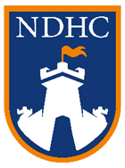

UNDER 18 MEMBER CONSENT *
It is the Policy of North Devon H.C. that parental consent is provided for participation, transportation and photography. The North Devon HC Members Code of Conduct and Safeguarding and Protecting Young People in Hockey Policy can be read on our website.
By completing this process, you give your permission for the following:
· I agree to my child participating in North Devon Hockey Club fixtures, coaching and training sessions.
· I consent to my child travelling by any form of public or contracted transport and/or in a motor vehicle driven by a member of North Devon Hockey Club or a parent attending the match/event
· I agree to photographs and video footage being taken to be used in the local press for sports news, Club promotion and on the club website. This includes any reproductions or adaptations of the images for all general publicity purposes

