

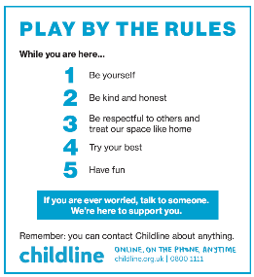
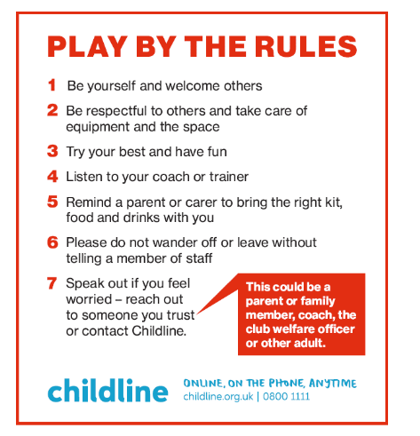
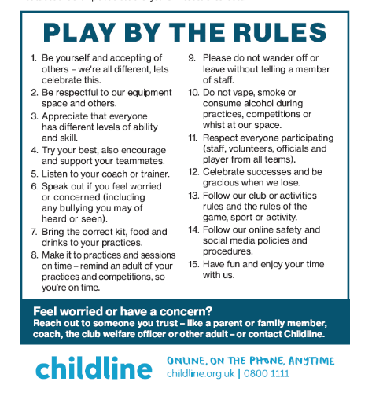
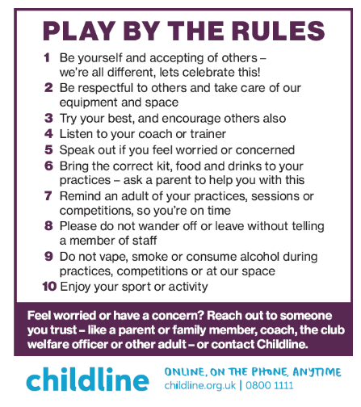
CODE OF CONDUCT
FOR CHILDREN & YOUNG PLAYERS
Code of Conduct for 8 to 12 years.
Code of Conduct for children under 8 years
Code of Conduct for 12 – 15 years.
Code of Conduct for 15+ years

