Ealing Hockey Club - Annual General Meeting Minutes
- Date: 28th June 2025
- Time: 20.00
- Location: Online Meeting

1. Welcome and Appointment of Meeting Chair
Dale Micklewright proposed Jeff Moores as the meeting chair for the day. Attendees virtually approved Jeff Moores as chair by raising their thumbs.
2. Approval of Previous Minutes
The minutes of the previous Annual General Meeting were approved as a true and accurate record.

3. Chairman's Report
Chairman Jeff Moores delivered a comprehensive report. He emphasised the club's continued growth and particularly highlighting the return of former juniors from university. He noted the success in all sections and thanked all volunteers, coaches, and committee members for their dedication.

4. Treasurer's Report
Heman Parekh presented the financial report, noting that the club aims to break even with proposed fees, with holiday camps and summer hockey being crucial for financial stability. Jeff Moores added that the club was £10,000 in the red last year but expects to manage through fundraising and sponsorships. The report detailed that funds are allocated effectively across both adult and junior sections, though specific investments were not detailed. The report was approved.

5. Secretary's Report
The Secretary provided an overview of administrative matters and membership numbers. While specific percentages were not given, the report indicated a strong and balanced membership across both adult and junior sections, reflecting the club's commitment to growth in both areas.

6. Coaching and Development Updates
Dale Micklewright provided updates on the junior section's growth, noting 300 members with representation from 55 different schools and a good balance between state and privately educated players. He highlighted successes such as 21 players representing London and the effective use of young leaders to umpire and run "little sticks" sessions. Challenges included an excessive number of girls' teams leading to coaching continuity issues, and low numbers in the Under 10 boys' section.
Sukhi Bhogal and Ed Parker emphasised player development, noting the success of moving promising players up age groups.
For the adult section, Dale Micklewright reported 24 adult members (defined as being 18+ as of 1st Sept 2024), with many juniors also playing for adult teams, providing an important pathway. The club’s second women's team last season grew in strength throughout the season and secured their position in the league and the Club intends to launch a second men's team next season to provide hockey provision for juniors moving out of the Under 16 age group, further demonstrating a balanced approach to development. Last but not least, with particular delight it was acknowledged that the Women’s 1s secured their promotion to Division 2 (a hearty well-done).
Jeff Moores announced that the previous evening we had learnt that Dain Lewis (Club President & Director of Coaching) is returning to Norfolk and a such would no longer be involved with the club. Jeff expressed gratitude for his contributions. He shared that Dain and Alex have developed a new coaching structure and a three-to-five-year coaching plan to enhance communication and improve player retention and recruitment across both junior and adult squads. It is sad that Dain won’t be able to directly implement this but grateful to Alex stepping up to deliver this across the Girls’ section with Anthony’s (Men’s Lead Coach) support. The club will be seeking a replacement Women’s lead coach along with a Talent Lead Coach. Sukhi will continue to lead the Boys’ section.

7. Election of Officers
Jeff Moores confirmed the following individuals will continue in their roles for another 12 months:
- Chairman: Jeff Moores
- Operations: Heman Parekh
- Secretary: Dale Micklewright
- Club Welfare Disciplinary: Datinder Lotay
- Non-Executive: Anita Clifford
He announced that Dain Lewis (Club President and Director of Coaching), Tejinder (Treasurer), Euan Macintosh (Club Captain), and Hannah Moores (Disciplinary) have stepped down.
The club welcomed the following new board members:
- Communications Lead: Rachel Wyn
- Treasurer: Yasho Shah (Chartered Accountant)
Both new appointments were approved by attendees. The club is actively seeking a Commercial Director and a Non-Executive Director.
The proposed Club's new corporate Structure was shared with an explanation on building better communication, seeking greater oversight and player experience.
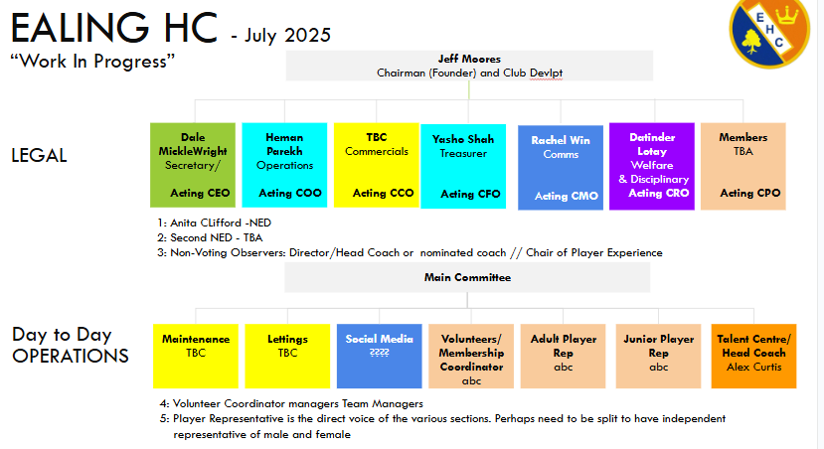
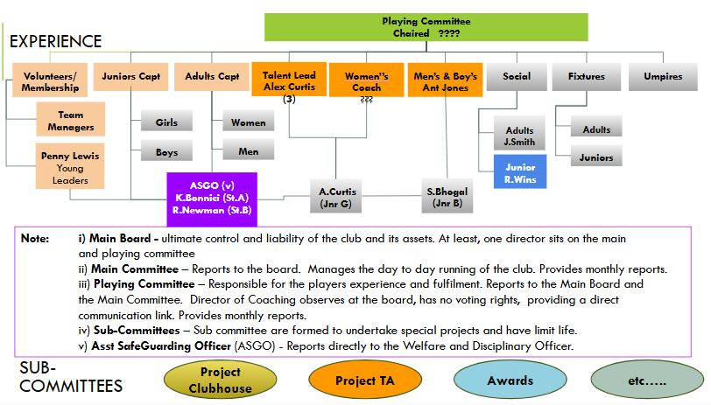
Over the coming months, key roles will need to be filled.
All those present approved the new structure.

8. Future Plans
Discussions on future plans centred around further strengthening the balance between adult and junior activities.
- Club Development and New Home Project: Jeff Moores updated attendees on the club's new home project at Perivale, next to the athletic track, which is now officially included in town and regional park plans. The goal is to have the first pitch completed by August 2026.
- Young Leaders Program: Dale Micklewright highlighted the program's growth to about 20 participants who support or lead Sunday morning sessions. Most young leaders have completed first aid and umpiring courses, and 15 have received achievement awards from the Jack Pete Foundation, with recent awardees funding new storage at St. Augustine's. This program fosters future talent for both junior and adult leadership.
- School Delivery Program (Charitable Foundation): Jeff Moores detailed the launch of a charitable foundation aimed at supporting disadvantaged and excluded students through school hockey delivery. As of September 1st, five extracurricular sessions per week will be delivered in schools around Ealing, with Gary leading three of these sessions. The program also successfully delivered the West London hockey finals.
- Holiday Camps: Dale Micklewright discussed the successful holiday camps at Fielding Primary, which generated approximately £10,000 in revenue and brought in eight new club members, demonstrating effective engagement with both junior and potential future adult members.

9. Any Other Business
- Non-Playing Members' Fees: Jeff Moores explained that non-playing members (including non-parent members) are required to pay a £25 fee. Half of this fee goes towards England Hockey membership and insurance, while the other half helps cover the cost of balls, equipment and sundries for social hockey sessions.
- Equipment Management: Sukhi noted improvements in equipment management, with Rachel organising social hockey bags and ensuring bibs are dry and well-maintained. The benefit of having crates for balls at St. Augustine's was also highlighted for clear inventory visibility.
- Club Season Restart: Dale Micklewright confirmed the club season will officially recommence on September 7th at St. Benedict's, following a summer break starting July 20th, with the competition season running until December 7th.

10. Date of Next Meeting
The date of the next Annual General Meeting will be confirmed.
11. Close
The Chairman thanked everyone for their attendance and contribution.

Minutes Approved By:
Chairman: _________________________ Date: _________________________
Secretary: _________________________ Date: _________________________

