DORSET CRICKET JUNIOR CODE OF CONDUCT
Remember: You are an important part of your Club. What you say and do matters.

PLAY BY THE RULES
1 Be yourself and welcome others
2 Be respectful to others and take care of equipment and the space
3 Try your best and have fun
4 Listen to your Coach or Manager and accept the decisions of Umpires
5 Remind a parent or carer to bring the right kit, food and drinks with you
6 Please do not wander off or leave without telling a member of staff
7 Speak out if you feel worried – reach out to someone you trust.
This could be a parent, coach, family member, the Club Safeguarding Officer or another adult.
Parley Cricket Club Safeguarding Officer is:
Tracy Rook – Tel: 07757663296, email: tracy.rook@live.co.uk
The Dorset Cricket County Safeguarding Officer is:
Vanessa May Tel: 07407619676 email: safeguardingofficer@dorset-cricket.co.uk
You can report something anonymously using this QR Code:
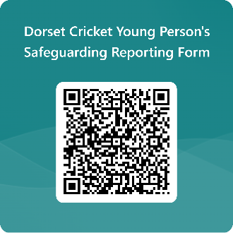

Childline: 0800 1111

