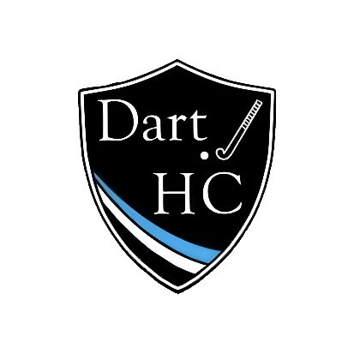
RE: Club Membership Fees for 2025/2026 Season
01/07/25

Dear Members,

After a very successful 2024/25 season and a restful summer break, we are very much looking forward to welcoming you all back for the start of the new season in the coming weeks. We are writing to you following the Club’s Annual General Meeting (AGM) on 24/06/25 where we discussed this upcoming year and finalised the membership fees for this coming season.

We passionately believe that hockey should be accessible to all, regardless of background, and that personal finances should not be a barrier to entry. As a committee, it is crucial that we balance this ethos alongside the importance of running a financially sustainable club. Whilst we continue to receive invaluable support from our sponsorship partners and fundraise through our many successful social events, the majority of our Club’s income is generated through membership fees. With rising costs of running the Club – from pitch hire to insurance to match teas, as well as a restructuring of England Hockey’s fee structure that has imposed additional costs upon us going forward - we have concluded that a 20% increase in membership fees is required in order for the Club to balance the books for this coming year.

Despite this increase, we feel that Dart Hockey Club membership continues to offer fantastic value for money, and our fees remain comparable to other local hockey clubs. The fees for the upcoming season, and what this includes, is outlined below:

Age Group | Early Bird (Paid by 30/09/25) | Standard Rate | Approx. cost per session:
Under 8s: | £121.50 | £135 | £5
Under 10s: | £121.50 | £135 | £5
Under 12s: | £121.50 | £135 | £5
Under 14s: | £121.50 | £135 | £5
Under 18s playing adult hockey: | £235.00 | £264 | £5
Adults: | £340 | £375 | £8

Your membership fee helps us to fund:
- Pitch hire for weekly training sessions, maintaining a safe, high quality playing surface for all to enjoy.
- Match costs, including the pitch, England Hockey insurance and umpires.
- Match teas after each game (adult hockey)
- Club equipment, including balls, sticks, goalie kit, first aid equipment, bibs and others.
- Teamo fees, allowing us to remain organised with match days and training, as well as our website.
- League entry fees.
- Umpiring fees and coaching costs (although the majority of the latter is done on a voluntary basis.

Financial Support
We recognise that despite the excellent value we feel this offers, in this current economic climate the membership fees remain a significant outlay. We are committed to supporting those members for whom the fees may be unaffordable, and therefore are pleased to offer discounts to the following groups:

- Those in full time higher education – £265
- Unemployed – £265
- Family rates – 5% discount for siblings in U14s and below not playing adult hockey.

If you have any concerns with regards to the membership fees or would like to see a copy of the accounts, please do not hesitate to get in touch with a member of the committee and we would be more than happy to discuss how we can support you with flexible options.

We are proud to be a family-orientated, supportive and inclusive club; Dart HC has continued to go from strength to strength in recent years, and we look forward to seeing this continue into 2026. We can’t wait to join you back on the pitch and celebrate the successes of our teams and players over the coming season.

Best wishes,

Dart HC Committee

