Minutes of Bath Buccaneers Annual General Meeting May 20th 2019.
University of Bath Sports Training Village.
Attendees
Nick Kendall | Sarah Cottle | Adam Sandey | Mark Whiteley | Eleanor Davies
Martyn Garrod | Rachael Webb | Caroline lavington | Joseph Durrant | Philly Lowton
Richard Starkey | Chris Witty | Amelia Lavington | Jo McDermid
Ian Cordwell | Sheridan Gyde | Julian Anderson | Claire Young
Toby Blong | Chris Jones | Tony Sheppard | Debbie Toogood

- Apologies.

Rich Bendry, Michelle Charlwood, Joanna Donkin, Sally Forndran, Stephen Herring, Kerry Kelley, David Lowrie, Marty Pellow, Lara Williams.

- Minutes Arising from last AGM.
Accepted.
- Matters Arising from last AGM.
None
- Presidents’ remarks-Tony Sheppard & Jo Carter.
None. Nick Kendall asked that the secretary contact Jo Carter and invite he to carry on in this role.
- Chairman’s Remarks..Nick Kendall.
Another full on season with many successes on the pitch. Congratulations to those teams & players
Congratulations to our Award Winners who received their Awards at the Annual Dinner
Some challenges off the pitch, especially surrounding the selection of ladies sides, from which we can learn in future seasons
Much of the discussion at lasts years AGM involved a wish to create/improve our sense of "One club" through social activity. This has proved very difficult to solve so more discussion on this later.
With one year left for our agreement with the University of Bath it is a time to reflect and plan a way forward. Again to be discussed later.
Looking forward to the challenges ahead and, in particular, the high quality of opposition we will see following promotion of both Men’s and Women’s 1sts Teams.
Big Thank You to all our officers/volunteers.
- Hockey Report..Ian Cordwell (Director of Hockey).
Success Stories:
- Girls U18 Tier 2 National Champions
- Ladies 1st Promoted to NL Conference West
- Men 1st Promoted to NL South League
- Ladies 2nds – West Premier
- Men’s A – Producing an oversupply of talent
- Men’s D – Champions / Promoted
- Men’s G - Promotion
- Ladies 6th Team to play league Hockey
- International recognition: Stu Rushmere, Tim Nurse, Olivia Hamilton, Sofie Hamilton, Nat O’Dwer, Louis Wrenn, John Jackson, Kate Jones
- Performance Centre/JAC: hoping to push more young players into senior teams
Goals 2019/2020
- Top 3 finish for both men’s and ladies
- Men’s A and Ladies 2nds promoted to Conference
- Increase umpire numbers
- Coaching provision across all teams
- Enjoyable Fun Hockey for all our teams
Umpires. (Nick Kendall)
- Fewer local appointed umpires due to retirements and pull up to NPUA to cover the expanded NL
- New Ladies 6ths, need to find club umpires for Ladies 2nds and Men’s C will increase pressure on our club umpire resources
- The age profile of our most active club umpires getting higher each year
- We need to ensure more members are qualified and active
- Team Managers will be asked to find at least two new recruits per team..moving towards each team having to release a player to umpire.

Challenges
- Pitch Time for training..difficult with just two pitches and lack of floodlights at satellite centres.
- Disciplinary..asking Executive to consider fines..£5 for yellow especially if dissent..£75 red cards?
- Coaching shortage of coaches
- Umpires 2 new recruits per team down to and including under 18s.
- University playing in Bucs NL. Travel times will increase for some and this may affect availability at weekends.
- Volunteers..especially needed for Ist XI Mens.
- New Rules..Four quarters of 17 minutes 30 seconds..no clock stop for penalty corners. (This is to be confirmed by EH). Will this affect (reduce) squad size that teams will be needing?
- Junior Academy Report.

Targets 2018/2019.

Produce U16 and U18 NAGs players

Increase the number of junior players with National League caps

Increase the number of juniors training and playing in senior squads

A teams to reach regional stage of EH cup

B/C teams development and upskilling

U8-U12 teams development, upskilling and membership retention

Results 2018/2019.

Produce U16 and U18 NAGs players
  - GB EDP: Stuart Rushmere
  - England U18: Ed Hewer, Louis Wrenn, Olivia Hamilton, Sophie Hamilton, Katie Jones
Source: EH 2018/19 observation camp list (published August 2018)
Increase the number of junior players with National League caps
  - National Conference West: James Hunt, Archie Foster, Alex Renwick, Nat O’Dwyer, Will Prentice
  - Indoor Premier League: Will Prentice, Pete Holdway, Stuart Rushmere, Louis Wrenn
  - EH Cup: Hugh Page

.Increase the number of juniors training and playing in senior squads
  - U18 Membership: Men’s: 32 Women’s: 8
  - U18 Goalkeepers Membership: Men’s: 3 Women’s: 5
  - This data likely to be inaccurate and challenge for website to keep data that is up to date.
  - Aim for training groups to be smaller, to focus coaching but this will increase waiting lists( to be discussed by executive).
A teams to reach regional level competitions
  - All teams reached target
  - U18 Girls Tier 2 finalists (11/05/19)
  - U18 Girls National Indoor finalists
  - Under 16 boys National Indoor finalists
B/C teams development and upskilling
  - U16 Boys B won Bristol Badgers League
  - U14 Girls B joint 1st in Avon Plate Central League
  - Player movement between A/B/C squads
U8-U12 teams development, upskilling and membership retention
  - Numbers remained stable (194)
  - Waiting list in some age groups (U12 Girls, U10s, U9s and U8s)
  - U12 Boys and Girls qualified for regionals
Proposal 2019/2020.
- Improve quality of coaching
- Offer more coaching CPD, supporting Director of Development Will contact local State and Private schools to try to increase the number of coaches in the club..estimate of 15 more needed.
- Introduce U14 indoor programme (Indoor Hockey UK Championships)
- Increase number of Hockey Festivals (under 10 and under 12). Possibility fo Bath League in early stages of development.
- Academy specific kit allocation..new system to be introduced this coming season.

- Development Report. Heber Ackland (not present at AGM).
  - Club Development Plan 2019 – 23
    - New version for 2019.
    - Supports ‘Club Mark.’ Newd evelopment plan will provide an important document in club’s application.
    - Looks to the future with new Club – University partnership.
    - Worth noting TBBHC is one of the 15 biggest Clubs in England and probably the biggest in the South West.
    - Vision: TBBHC offers hockey at all levels supported with excellent facilities, quality coaching and an inspirational environment to help all our members old and young to aspire to the standard they want to achieve from recreational to international standard.
  - Coaching Development:
    - Successful 3 year partnership with England Hockey has delivered:
      - 3 x UKCC Level 2 England Coaches.
      - 13 x UKCC Level 2 Sessional Coaches (a further 7 have started).
      - 60 coaches have attended a GB Coach Club Course at Uni.
      - All Level 2 coaches have undertaken the Safeguarding Course.
  - Coaching Course Opportunities at STV:
    - Sunday 18 Aug 2019: Coaching design and shaping session with Toby Blong and Heber Ackland (for all coaches).
    - England Hockey due to run the following courses at the STV:
        - Summer 2019 (date tbc): Level 1 Introduction to Hockey Course.
        - Sunday 8 Sep 2019: GB Coach Club Course.
        - Summer 2020: UKCC Level 2 Sessional Course at STV.

- Social and Fund Raising.
Unable to form committee in 2018/19. Thanks to those who did organise events eg Quiz Night. Thanks to all those who supported the Club Awards Night and special mention to Ian Cordwell for his organisation of the evening.
Area of club where we need to do more. Perhaps link events to charity including hockey disabled? More activity based may attract more youngsters. Suggested that there could be a ‘team of the month’ to organise event but this needs a coordinator! Awards night needs to be supported more; part of the role of team manager to make sure teams support this; date could be published earlier to help with this. Ist XI men have offered to organise dinner/awards next year.

- Marketing and Publicity.
Thanks to Harriet Montgomery especially for her work with respect to social media links. Area of club where there is much potential and executive looking to resource new initiatives. There is a new social media policy. Club would like to hear from anyone who can take on a new role of Social Media Coordinator. Links to Facebook and Twitter already established but so much important club news does not find its’ way onto the social media platforms and generally support and promote the Club.
- Finance.
2018/19 Season -
- Income generated £130,327 up from £101,705
- Paid members 642 down from 699..not as large a drop as expected.
- Increased costs due to Junior Academy increases for Director, extra coaching, training pitch time and equipment costs.
- Excess costs this year as a result of late coaching claims for 17/18 (£1,560) and from match fines and cancellation costs which amounted to £1,518. (much larger than anticipated)
- Ignoring any sponsorships or rebates we actually made a Deficit on playing income and costs of £17,044 which was up from £16,903 for 17/18.
- Pitch rebates however offset this by £11,616. This is being discussed with the
University, as the current agreement runs out in August 2020. A very important source of income to offset playing deficit.
- Gift Aid via Advalus sponsorship, GGR junior sponsorship and a few donations added £6,297 of income. This was down from 17/18 as a result of Fidelius withdrawing their sponsorship and no income from Junior Leagues, in total dropping £2,704.
- We budgeted for a slight profit of £318 but actually achieved £991, despite the above items.

2019/20 Season –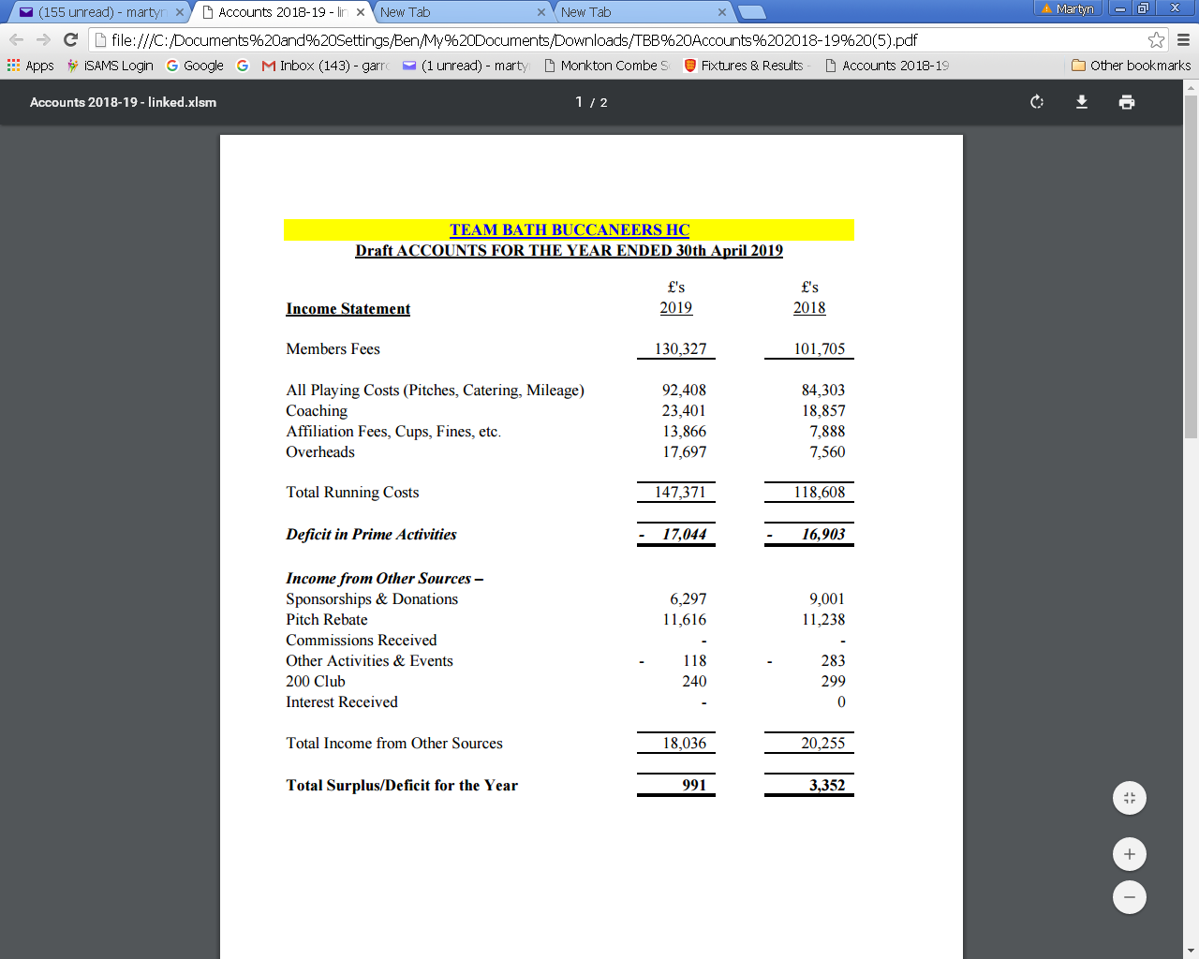
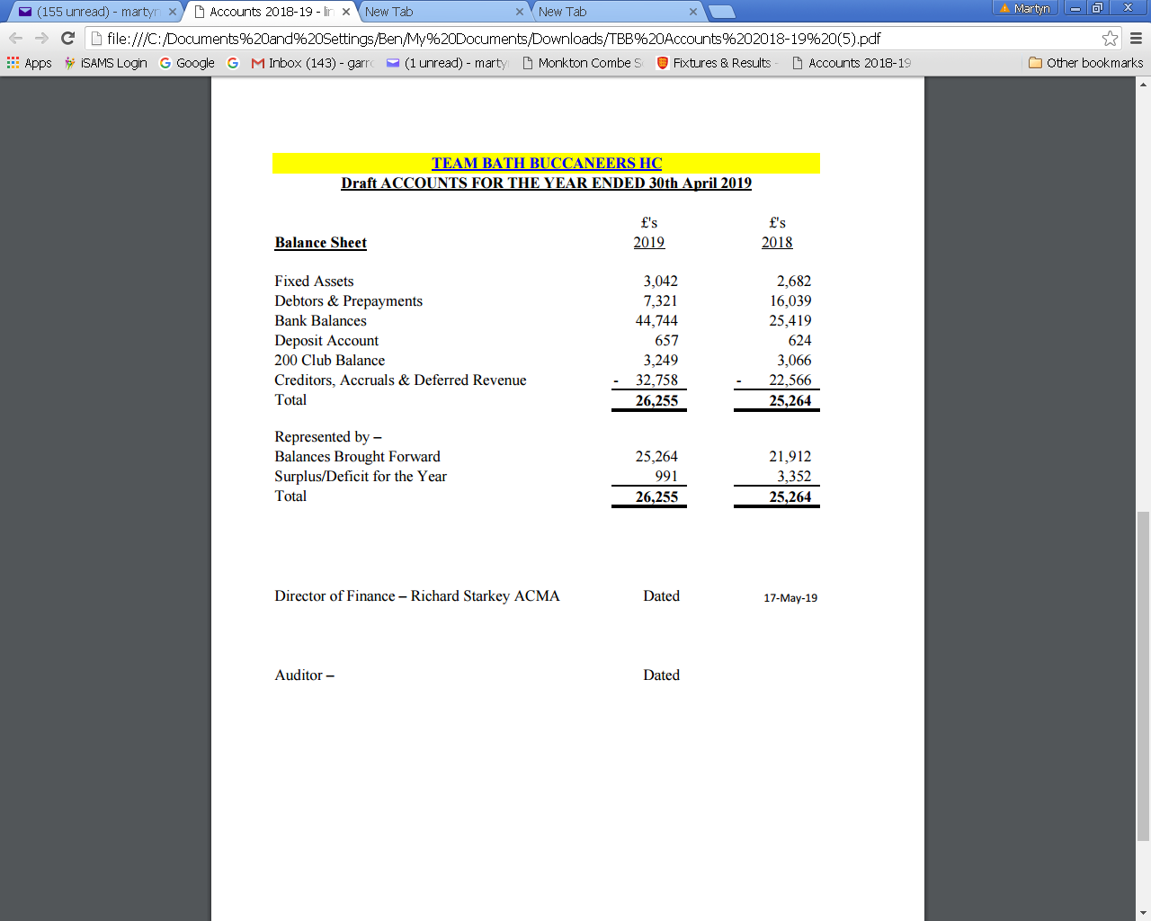

- 2019/2020
- We need to budget for 1 extra Ladies team
- General inflation at 2% on most costs
- Membership assumed at this year’s level
- Proposal to increase all fees by 2% (up to £375) except for Juniors who will only increase by £1 to £200…this was passed
- Increase in 200 club take up
- If the above items are agreed, then a 19/20 surplus should arise of circa £2,897.
- It was agreed that the website could carry a pie chart showing the approximate distribution of each players membership fees..how much goes to pitch hire, catering, equipment, coaching, umpires, affiliation, mileage.
A question was asked about paying of mileage costs for the last season and the treasurer agreed to look into this in the next day or so.
Accounts for 2017/2018 and 2018/2019 to be audited by Annette Pellow who will then resign this post. New auditors required for 2019/2020.

12.Commercial & 200 Club.
Sponsorship package has been updated with some new plans
Thanks to SITEC sponsorship now in its final year.
Thanks to GGR from Worcestershire the new Junior Academy sponsors providing £6000 over two years.
Thanks to Advalus for continued sponsorship of Men’s 1st XI
Thanks also to Royce Clinic and John Moore’s Sports
200 Club Report May 2018- March 2019
Currently only 26 members, compared to peak of over 60 in the 13/14 season (when it was included as membership option on website).
Winners over the last year include John Matthews, Stuart Wyer, Brian Wyer, Marty Pellow, Nicola Wilson, Robert Crutchley, Howard Silcox, Anthony Locke, Guy Bartlett, Nicola Richardson, Chris Church, Nick Kendall, Dave Smith, Philippa Ashman, Nick Brown, Dudley Bartlett. Leaflets available here today – help yourselves and sign up!
There is now a link to the 200 Club on the website, where you can easily sign up and pay!
This year’s income
Total income £570 Profit = £230
Prize Money £340
Future options
Add a Buccs membership option to include 200 Club Membership. This would effectively increase senior membership to £399 (£24 for one year membership). It was agreed that this could be offered with members able to ‘opt out’. This will not be available to Junior members.
If 100% of seniors paid £24 then we would collect 112 x £24=£2,688..with 40% retained this would give a profit of £1.075. If every member of the club joined(!) this could be a profit as large as £6,144.
Team Bath Buccs Sponsorship Raffle.
Everyone who enters receives;
1 entry into yearly draw. A minimum of 8 entries will be needed to make this viable.
Logo and link on website sponsor pages.
Advertisement on club notice board.
An invitation to every home game. Logo in match day programme.

Winner of draw receives;
Sponsorship of Men’s and Ladies 1st first team shirts.
Logo on home and away shirts for season 19/20.
Logo and hyperlink on website
Pitch side advertisement 2 boards.
Website Advertisement with link to sponsors website
High Profile on Facebook, Twitter etc.
2 tickets to the annual club dinner.
An invitation to every home game.
Press release/launch at the first home game of the season.

Cost to enter = £350 per entry.
Please note that all entries will need to comply with the TBB Sponsorship codes of practice.

- Closing date for all entries 15th July 2019
- Welfare Report. This season the number of volunteers working within the Junior Academy has increased from 60 to 75.
All Junior Academy Coaches and Managers have been DBS checked via England Hockey.
This season all Coaches and Managers within our Senior Teams have also been DBS checked.
  - The following polices/procedures have been introduced:
    - Changing Room Policy for Juniors Playing in Adult Teams
    - Pre season Safeguarding Meetings for Junior Academy Managers
    - Accident Reporting Form
    - GDPR Policy for Under 18’s
Going Forward 2019/20
Restart DBS process for all Managers and Coaches across the Junior Academy and Senior Teams.
Continue to promote the importance of safeguarding and good practice in accordance with the England Hockey Safeguarding Call to Action.
Ensure that all people working regularly with U18’s have relevant safeguarding training.
14.England Hockey.
The new National League structure kicks off next season.
Nick Kendall sits on the England Hockey Elite Domestic Panel which is charged with developing Performance Club Hockey to raise standards and increase its commercial viability. This is slow progress as Premier Division Clubs unwilling to change. Hopefully this will change in the next year.
The Governance Review is another slow process with another survey of clubs due any day now. Basically the aim is to simplify structures, reduce the number of volunteers needed and increase control by EH professionally. More up-dates from EH by September.
Chief Executive Sally Munday, who has been the driving force behind all progress in the last 10 years, leaves in the Autumn to be COE at UK Sport. Interesting to see how this might change policy etc.
15.University Up-date.
Current agreement with Bath University ends in August 2020; there is a working party charting progress in this regard.
Pitch 1 – Plans to replace asap but University have significant money constraints at the moment.
Review of Flood Lights undertaken and proposal to replace with LED
Outside fixed cameras and scoreboard now in place
University teams in Bucs NL
3 G pitch (training area to be completed by year end). At one stage a larger training area had been expected.
Bath Buccs have a sub-committee of 15 looking into the new agreement. Questionnaire completed with 150 replies and contingency plans being drawn up before meeting with University. The negotiations are likely to be long and tough with no 10 year deal on offer (more likely to be 3 year deal). This agreement will probably form the focus of the AGM in 2020.
16 Proposed Amendments to the Constitution.
Toby Blong the Junior Academy Director has been elected to the Executive Committee.
17. Election of Non-Executive Officers.
There were none proposed.

18. Election of Officers.
A vote of thanks for all Officers for their hard work over the past year was proposed, seconded and passed. Posts for the coming year were approved:_
Executive Committee.
Presidents | Tony Sheppard & Jo Carter
Chair | Nick Kendall
Vice-Chair | Sheridan Gyde
Club Secretary | Martyn Garrod
Director of Finance | Richard Starkey
Director of Hockey | Ian Cordwell
Director of Junior Academy | Toby Blong
Commercial Officer | Sarah Cottle
Welfare Officer | Rachael Webb
Social and Fundraising Chair
Director of Marketing and Publicity
Director of Club Development | Heber Ackland
UOB Student’s representatives
Member Representatives (min x6) | Claire Young Adam Sandey Chris Jones Eleanor Davies Marty Pellow
Hockey Committee
Men’s Club Captain | Ian Cordwell Teams 1-2  Marty Pellow Development
Ladies Club Captain | 1 & 2:  Philly Lowton Development
Hockey Secretary
Head Coach | Jody Paul
Ladies Match & Fixture Secretary
Men’s match & fixture secretary | Nick Kendall
Pitch Secretary | Nick Kendall
Membership Secretary--Mens | Heber Ackland
Membership Secretary Ladies 1/2 | Dai Bevan
Membership Secretary Ladies 3/6 | Jo Donkin
Membership Secretary Juniors | Jo McDermid
Umpires Coordinator | Nick Kendall
Men’s League Liaison Officer | Nick Kendall
Ladies League Liaison Officer | Sheridan Gyde

Social and Fundraising Committee
Chair
Secretary
Team Representatives

19. Any Other Business
a) Could a flow chart be put on website to explain the club structure; which member of the committee deals with each area.
b) Players should be aware of the terms and conditions on the web-site which shows that personal injury is not covered. Treasurer said he would look at this again but the premium is likely to be well in excess of £1000
c) Selection of teams 2019/2020. Director of Hockey reported that all teams will be using ‘’Teamo’ to show availability and selection. This should make it much more transparent for managers to see who is moving between and within teams.
d) Director of Hockey encouraged managers to send e-mail to explain why a player has been dropped. It was stated that face to face explanations are usually better.
e) Use Clubbuzz for administration and Teamo for team matters.
f) At the next Exec there will be a discussion about extracting payment information from Club Buzz so that managers will not select any non players after the middle/end of October.
g) Training schedules are not yet decided.
h) Paying mileage to individuals has not been completed (see in finance report) and will be assessed again in the next few days.

Meeting ended 20.55 with Chair expressing thanks for attendance.

MCG

