Minutes of Bath Buccaneers Hockey Club 23rd Annual General Meeting

Held on Tuesday 2nd June 2015 at 7pm, Bath Golf Club

Attendees

Nick Kendall | Nik Richardson | Nicky Wilson | Richard Starkey | Heber Ackland
Debbie Toogood | Carolyn Rolleston | Tony Sheppard | Marty Pellow | Chris Jones
Andrew Silcox | Rob Prentice | Chris Witty | David Horler

- Apologies

Claire Connell, Sam McArthur, Andrea Holder, James Symons, Pete Squires, Chris White, Steve Clarke, Mike Hill, Dan Cattermole, Rachel Taylor, Sophie Field, Jo Carter, Anna Butler, John Williams, Rachael Webb, Claire Toogood, Vikki Sage, Netty Pellow.

- Minutes of last AGM

On the website and distributed at the AGM, accepted.

- Matters arising from last AGM

None.

- President’s remarks – Tony Sheppard & Jo Carter

Shep welcomed everyone to the AGM. Another fantastic season - congratulations to the club as a whole for a great season: all the Junior Academy results; the Ladies have possibly had the best season with 3 teams promoted; the Men’s section with the 1s getting to play-offs and not quite making promotion to Premier League, the B team were promoted, the middle section of the club has done very well. Shep thanked the players for their efforts but pointed out that clubs are half players, half members on committee and people who run the club. Thanks to the people who run Sunday mornings for our developing Juniors who will come up through the club. Thanks to the other people who contribute to other people who run the club, in particular the Exec for future thinking and organisation. The Club has been very lucky to have people like this. The Club is 60 years old next month and we have always had a good committee and always moved forward. Shep remembered David Davenport who sadly died this season. Shep ended by thanking the Club for inviting him and Jo to be the Club Presidents.

Jo Carter’s comments sent in her absence;

Another successful season for Buccs. Jo re-emphasised last year’s points that running a club does not just happen by playing and competing; it takes vision and hard dedication behind the scenes to make a club successful. Buccs is lucky to have a strong team working on the players’ behalf and these people deserve the biggest thanks. There are too many to mention but to mention a few – Nick Kendall, Heber, Marty, Nicky and Nik. Unfortunately they cannot keep going on year after year the club needs more support and fresh ideas. Jo stressed this is everyone’s club - make it even better, get involved, join a committee, air your views and take the club to yet another dimension! Jo finished with saying good luck for the next season from the juniors to the seniors.

- Chairman’s Remarks – Nick Kendall

- The Club has been revitalised – there’s a great sense of energy and enthusiasm for the club. A lot of this has come from Heber, but has spread through the Club from Juniors to Seniors.
- The Club has been lucky with the officers who have created that environment and created a positive feeling.
- FB and Twitter have been a major contribution towards the media ‘explosion’ and enhanced club communication.
- Player and team successes. Congratulations to all those involved.
- We have made it into the England Hockey Top 30 Clubs.
- Personal thank you to all members and committee members. This has been the easiest season as Chairman for a long time.
- Ongoing similar challenges to last year (recruitment, finances, volunteers).
- The Wally Haymond Tankard for Club Person of the Year was awarded to Heber Ackland for 2014/2015, at the annual dinner. The Junior Club Person of the Year was awarded to Joseph Bird.

- Hockey Report – Heber Ackland (Director of Hockey)

Video on TBB website showing 2014/2015 season successes: https://www.youtube.com/watch?v=SOkiimd1Hp8

- Where we were this time last year - teams were struggling at most levels, some teams had been relegated, playing members were low.
- Targets from last year’s AGM were for 3-4 teams to get promoted, 0 relegations, retain Prem Indoor position (men’s indoor), boys and girls U18 to make at least quarter-final stages and club teams to solidify performance.
- Most of these targets have been achieved if not superseded – ladies 2s, men’s Bs, ladies 3s and ladies 5s all got promoted, men’s 1s, ladies 2s, men’s Bs and ladies 3s were all league champions, U18 boys were bronze medeallists, Club sides were much more competitive and playing numbers were up.
- However, the Men’s Ds and men’s indoor got relegated.
- We need to capture individual successes on the website, not just international honours.
- Matchtight has written an article on successful ex-Buccs who have gone on to play for other top teams, e.g. Wimbledon.
- Looking ahead at Performance teams – there is a turnover of experienced players, however players leaving the club/team opens a space and an opportunity for others so is a positive for the club. There will be a change to the ladies 1st team coach. The ladies 2s need to hit the Premier League running. The men’s As need to continue to be competitive in the Premier Division and National Cup. The men’s Bs should push for further promotion. The men’s indoor should aim to return to Premier League.
- Looking ahead at Club teams – we need to maintain strength in depth and competitive focus, find a way forward for the for the men’s D team (now E team) in consultation with the Uni (and if it doesn’t work, we need to be prepared to go for full integration into the club the following season), we need to try to prepare better for the “February Challenge” (when there are low numbers in the club).
- The Hockey Festival / Club Day is Saturday 5th September.
- Junior Pathway – looking to pull through more U18 players and improving management of junior players.
- New rules – on the website
- New EH Coaching Pathway is out – more flexible.
- Junior Academy – lots of success, membership is very healthy. The largest club junior academy in the West Country.
- Volunteer / parents – need more support for these people.
- Need more pitch time really.

Club Awards:

- Men’s Player of the Year – Sam Hatherley
- Men’s Young Player of the Year – Alex Witty
- Men’s Most Improved Player – Chris White
- Men’s Top Scorer – Kyle Barnes
- Ladies’ Player of the Year – Gillian Kane
- Ladies’ Young Player of the Year – Jess Moore
- Ladies’ Most Improved Player – Yaz Scarr
- Ladies’ Top Scorer – Claire Connell
- Coach of the Year – Carolyn Rolleston
- Les Lovelock Umpire Award – Royce Menezes

- Development

- One Club approach. Aims are for more club events, to strengthen membership, have ambition and performance targets, better coaching, partnerships and benchmarking, improve facilities and promoting the “Having Fun” Club ethos.
- The new playing kit was introduced this last season and is part way through the transition phase. Looks really good. Thanks again to Mark Blackham for sorting this out.
- There’s a new Club Coaching Framework in place for next season. Payment will reflect qualifications, so will incentivise people to be qualified and improve their coaching.
- The new website has generally been very good and social media (Facebook, Twitter, YouTube) has been an excellent form of communication.
- Possible twinning with a Dutch club to share ideas.
- England Hockey Clubs Strategy –TBBHC is one of the top 30 clubs in the country.
- The Club Development plan is being progressed including ideas for a Clubhouse.

- Social & Fund-raising Committee Report

- 4 socials were planned, 2 before Xmas, 2 after. The February one didn’t take place. On the whole they were well-attended by a good cross-section of adult members and the focus was on informal social events rather than fundraising with the exception of the club dinner which raised £715 for the club mainly due to the successful raffle.
- For next season, a schedule of 2 organised club events before and after Christmas + the dinner thought a successful format to ensure good attendance at every function. These organised events complement the informal team and friendship group socials that are not formally organised by the Social Committee. Proposal is to focus on 2 social events & 2 fundraising events.
- Post-match activities - the lack of a clubhouse pitch-side is often quoted as contributing to the lack of after game social atmosphere and little socialising between teams. The Lime Tree as an after match venue on campus may help encouraging members to stay after games and also to return pitch side and support other teams. (Wait to hear about this in Any Other Business.)
- 200 Club report May 2014 - April 2015 - total paid in: £1062, total prize money: £576, profit: £486. Membership numbers dropped suddenly this season (from about 60 to about 30). This was most probably due to not having easily accessible option on website to join when paying subs. Those members remaining are mostly standing orders that have been running for years. It would be good to be able to "opt out" when selecting membership category on website again.

- Marketing and Publicity Report

- Andrew Eversden and the men’s 1s did a lot to find 1st team player sponsorship – the match programme was paid for by sponsors. The ladies 1s also found individual player sponsorship.
- The men’s game V Barford Tigers was livestreamed and went viral.
- Bath Uni would be prepared to livestream every game, but at a cost – need to get a sponsor (~£500/game).
- Galvanised Hockey – match highlights can be shown on their website for free (Heber).
- There was an article about TBBHC in NOW Bath magazine.
- Andrew visited a large number of local businesses. No particular initiative came out of it but hopefully this was good groundwork for future work.
- There was an article about Andrew and his time at TBBHC in a Dutch hockey magazine which promoted opportunities to play in the UK.
- FB and Twitter have helped with Marketing.

- Finance Report – Richard Starkey

Summary

Team Bath Buccaneers 2014/2015 Income Statement

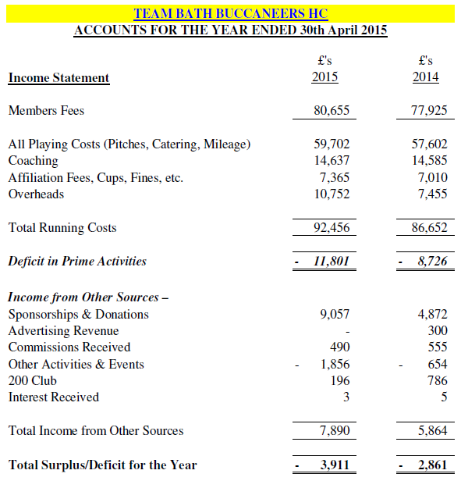

Notes on the Income Statement:

- Increase in member fees (increase in membership as targeted)
- NB still collecting £11k of fees. RS confident we can get these in.
- Playing costs slightly increased on last year as anticipated.
- Overheads slightly up – because of team successes – success budget.
- Mileage was an overspend due to fixtures and one team having to use public transport. More drivers next year hopefully. Also we entered more competitions and always got the away draw.
- £11.8k deficit – need to get this to be 0 (break even) if we want to move forward and start a clubhouse fund etc.
- Non-playing income is a lot higher this year: Advalus sponsorship and Giftaid (£3k including back-claiming from 2010), Charles Stanley sponsorship, Men’s 1s and Ladies 1s individual sponsorship, kind donation from Shep.
- Other activities lower than last year. Back to Hockey – over £700. Festival – has generated nearly £1600 so far.
- The 200 Club figure is lower than in the Social & Fundraising report because we paid out some old prizes this year.
- Total deficit for the year is £3.9k.

Team Bath Buccaneers 2014/15 Balance Sheet

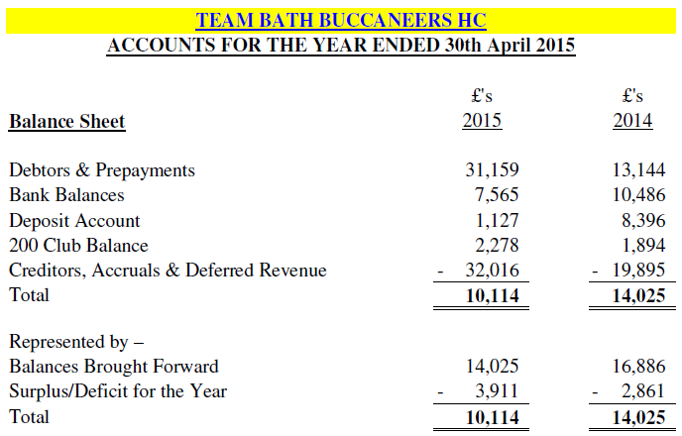

Notes on the Balance Sheet:

- Tight on cashflow at the moment.
- It is very important that we control our membership subs and improve prompt membership collection (last year this started a month late due to website etc.)
- RS wants to get the total higher than £10k to fund Heber’s development plans.
- In summary we are healthy at the moment.

Summary budget

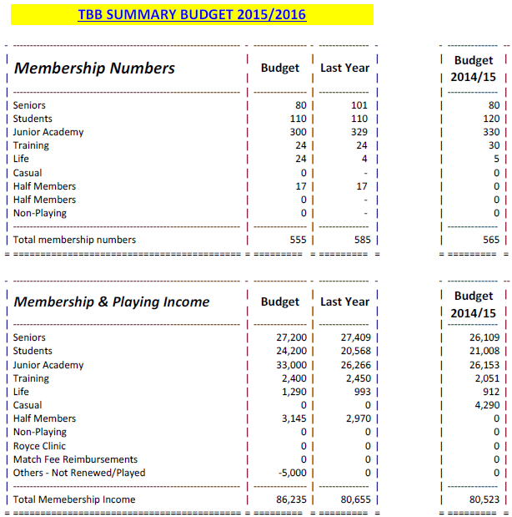

Playing costs

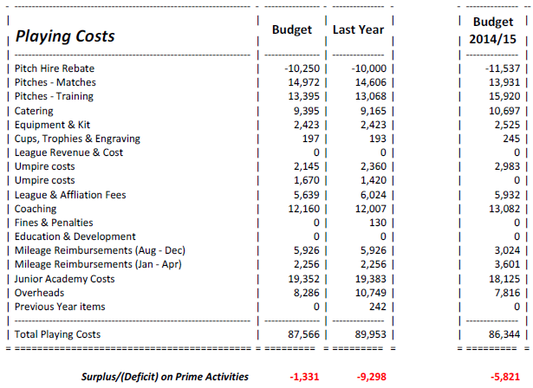

Notes on the Playing Costs:

- Pitch rebate is over the 10 year programme/deal with Sitec. We are approx. 5 years in.
- We would still be slightly negative if we achieve the budget. Aim for £0 though.
- This includes Heber’s new coaching structure/proposal.

Income from other sources

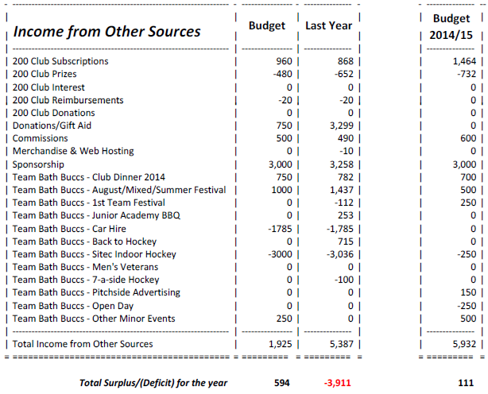

Notes on Income from other sources:

- All 1st team sponsorship will go through Richard next year so he sees all money movements. Agreed with JW.
- Overall we should be £594 in profit, according to the budget.

Overhead costs

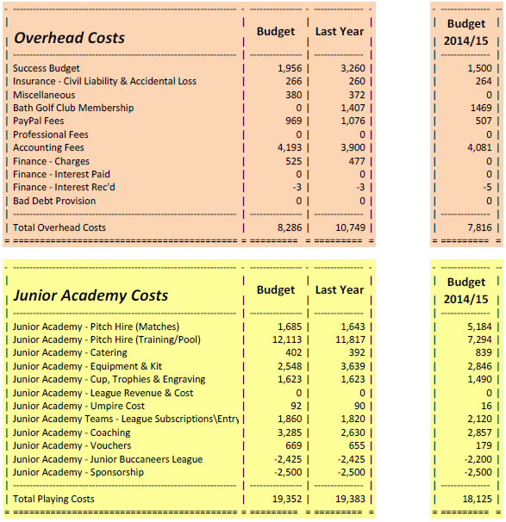

Membership proposal

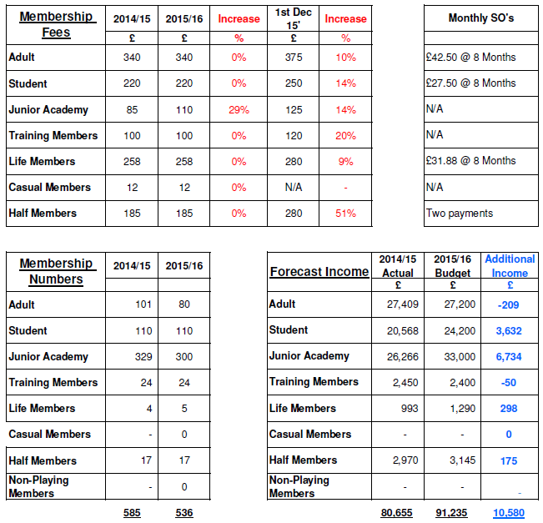

Notes on membership proposal:

- Junior Academy price increase proposal has been made in line with other clubs in the country and general feedback from parents.
- There should be a possible additional membership category for U18s and U16s who don’t get as many games. Also there are some U16s/U18s who aren’t in the first team in those age groups so get fewer games.
- NK is talking to 2 potential sponsors for the Junior Academy, not confirmed yet.
- Possible slight increase in other membership areas.
- NK recommendation is that we agree an increase, but shouldn’t finalise at the AGM, awaiting confirmation on sponsorship news. Minimum of £95 for Junior Membership.
- NK has meetings with JA managers/coaches in the next few weeks.
- The incoming Exec to confirm increase after next meeting, based on the mandate that the rates need to go up. RS – can’t rely on sponsorship. This may be a structured increase over a couple of years.

Other points of discussion:

- Problem with payment and financial reporting functionality on the new website - ClubBuzz will improve functionality if enough clubs request it. Something we can look to improve.
- RS proposing that we put all categories up marginally by ~2%.
- Link membership costs to increased costs, e.g. pitch costs. (New pitch costs don’t get released until ~ Aug.)
- Mandate for Exec to look to increase all membership subs subject to NK finding out what pitch cost increase is going to be.

Thank you Richard.

- Commercial Report – Nick Kendall

- Geraldine has been working behind the scenes.
- 2 possible Junior Academy sponsors. NK is trying to get one of them to look at senior club sponsorship.
- We are pleased that Advalus are carrying on with their sponsorship of the men’s 1st team.
- Pitch-side advertising is declining – none left now. Need to increase this.
- There are also opportunities for goal sponsors.

- England Hockey Update

- Club First expired. NK is working on this, to be done by start of the season
- TBBHC has been named in the Top 30 clubs in the country.
- Coaching and umpiring re-vamp.

- University Update

- Uni is still targeting to increase student numbers by 30% over the next 5-7 years. On target. Lots of building.
- Improving student Performance Student applications.
- New joint Deputy VC – Steve Egan (ex Buccs hockey player).
- Coaching budget has been affected by the new BUCS points initiative – the Uni is focussing on fewer higher standard teams. Top 3 hockey teams at the Uni (men and ladies) will be pressured to perform better, which they will do if the players participate in Club hockey at weekends. More emphasis from the Uni hockey committee to play club hockey.
- The Sitec pitch is not in best state at the moment. The ongoing pitch repair issue will probably go to court. Ongoing maintenance will start again (brushing etc.). The water system is in a state of collapse – the Uni will need to invest in new jets. An electronic scoreboard and LED lights will be installed at some point in the future.
- Action - NK to look into rebate/reduction for lack of watering by the Uni.
- Action - NK to look at options with the match schedules for increasing watering/managing fixtures so Sitec gets watered first game of the season.
- It was noted that the Mariners would prefer to play on Pitch 1.

- Proposed Amendments to Constitution

- None

- Elections of Non-Executive Officers

Elections of the Non-Executive Officers followed:

- Presidents – Jo Carter, Tony Sheppard
- Vice–Presidents (New) – Elaine Davenport (on behalf of the Davenport family), Nicky Wilson. Malcolm Robson died this season.
- Life Members (New) – Tim Davenport.
- Auditors – Julian Anderson standing down. Netty Pellow has agreed to do this, post AGM.

- Election of Officers

- Executive Committee:
Chair | Nick Kendall
Vice-Chair | Janet Gubbin
Club Secretary | Nik Richardson
Director of Finance | Richard Starkey
Director of Hockey | Heber Ackland
Commercial Manager | Geraldine Hudson
Social and Fundraising Chair | Vacant
Director of Marketing and Publicity | Vacant
Director of Club Development | Heber Ackland
UOB Student’s Representative | Harry Black
Member Representatives (min x6) | Nicky Wilson, Marty Pellow, Pete Squires, Sophie Field, Chris Jones, Dan Cattermole

ii) Hockey Committee
Men’s Club Captain | Vacant
Ladies Club Captain | Nicky Wilson
Hockey Secretary | Vacant
Head Coach | Jody Paul
Ladies Match & Fixture Secretary | Lauren Urch
Men’s Match & Fixture Secretary | Nick Kendall
Pitch Secretary | Nick Kendall
Membership Secretaries | Nicky Wilson to arrange ladies. Men’s – Marty Pellow. JA - vacant
Director of Junior Academy | Vacant
Umpires Coordinator | Vacant
Men’s League Liaison Officer | Nick Kendall
Ladies League Liaison Officer | Nicky Wilson to delegate or do herself.

iii) Team Captains/Managers
Mens 1s | To be elected on appointment of men’s club captain

Mens A

Mens B

Mens C

Mens D

Mens E

Mens F (Mariners)

Mens G
Ladies 1s | To be elected by incoming committee

Ladies 2s

Ladies 3s

Ladies 4s

Ladies 5s

Social and Fundraising Committee
Chair | Vacant
Secretary | Vacant
Team Representatives | Sophie Field (200 Club)

Non-Exec Appointments
Men’s 1st XI Coach | Jody Paul
Ladies 1st XI Coach | Adverts have gone out
Physiotherapist | The Royce Clinic
Associate Membership Secretary | Vacant
Webmaster | Heber Ackland

- Any Other Business

- Lime Tree (new café/bar on campus) proposed as new location for match teas, socials, meetings - located at end of East Car Park. There’s a bar, multi-food outlets & Costa Coffee. Opens 7 days, 11am-11pm. Food for teas would be £3.15 per person from a standard 4 choice menu. A voucher system would be used so we would be invoiced for actual spend. Cost is equal to BGC. Option for members to pay for added value to meals e.g. side salads. Supporters can buy food. No dress code. Not exclusive but big space and quiet most weekends. Unlikely to have to use Cross Keys. Not suitable for formal dinners put informal parties, Awards Nights fine.
- Proposal agreed.

Meeting concluded at 9:35pm.

